Overdale Community Primary School
Year 4 Spring Term 1 - 2025
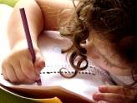  Literacy  In our Talk 4 Writing this half term our fiction focus will be writing warning stories including dialogue. We will use our new text ‘Staying Out’ to help guide us through our writing. Our non-fiction text will be an explanation text where will focus on using diagrams, bullet points and linking paragraphs with a range of conjunctions. | 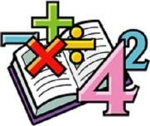  Maths  In maths, we will continue to focus on multiplication and division, multiplying and dividing by 10 and 100 and using formal written methods to multiply 2 and 3 digit numbers. We will the move on to our fractions unit, where the children will learn about equivalent fractions and adding and subtracting fractions. |   Science  Sound is our focus in science this half term. We will be how sounds are made and how vibrations affect how sounds travels and its volume. We will also investigate the properties of the objects making the sound. |   Computing  We will continue our learning about coding using the Scratch programme and will begin looking at computational thinking and programming.
  Humanities  In humanities we are going to explore what life was like in Victorian times, as a significant time in our history and how this affects our lives today. | Our class book  The Boy Who Met a Whale  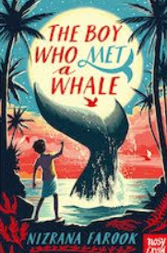 |  | PSHE  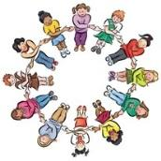  In PSHE, we will be thinking about safety and the changing body. We will be focusing on staying safe online and thinking about some of the changes that come with growing up.
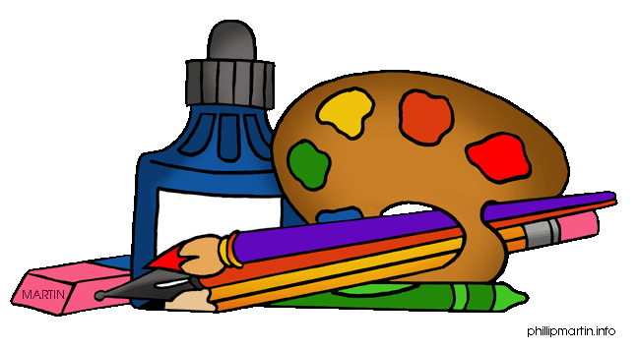  Art  In Art we will explore pattern and develop a range of technical skills and knowledge through drawing and collage.  We will learn how pattern can be a mindful activity, and that as humans we respond to patterns made by other people. | 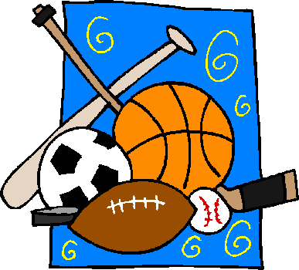  PE  For games this half term, we are working with Ivan in golf and working to develop our flexibility, strength, technique, control and balance in gymnastics. |   French  In French, we will extend our learning of the numbers in French as well as learning the days, months and various celebrations that take place across the year. |   RE  In RE, we will learn about the importance of Festivals in religious communities.  Music  In music we will continue to develop our ensemble skills, now incorporating melody and accompaniment using either the glockenspiel or recorder.

